**SQL Project Questions:**

1. **Basic Queries**
   * **List all cars manufactured after 2015.**
     + 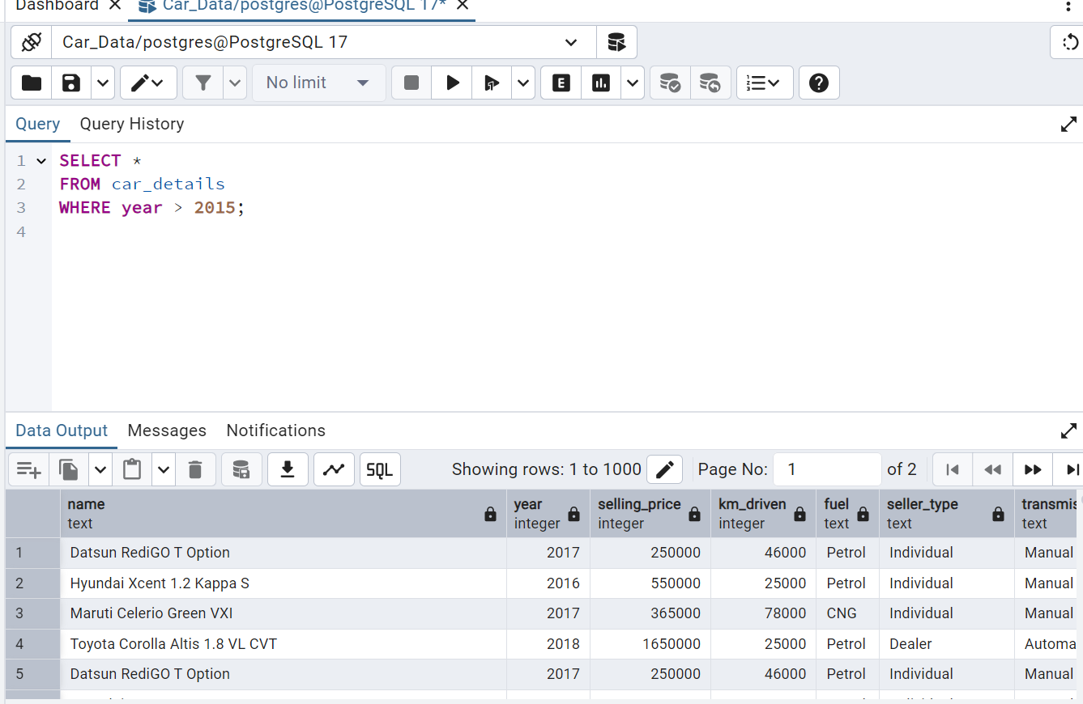

* **Find the most expensive car in the dataset.**

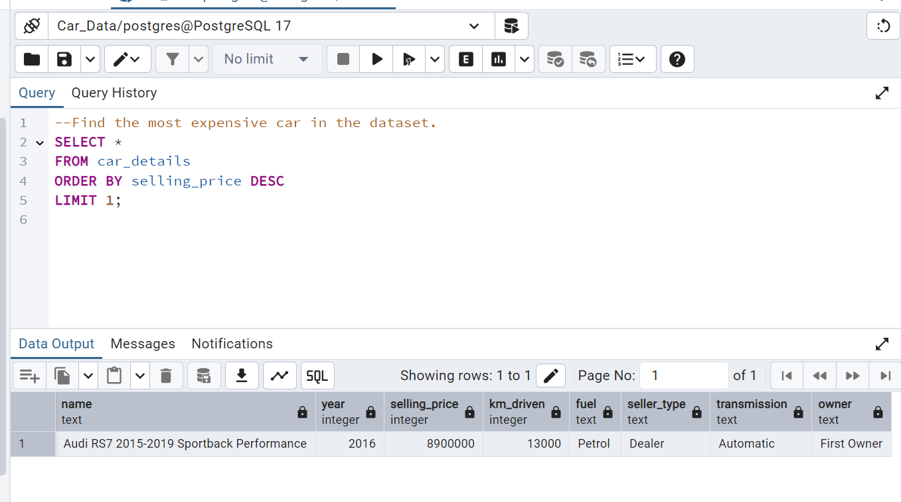

* + **Count the number of cars for each fuel type.**

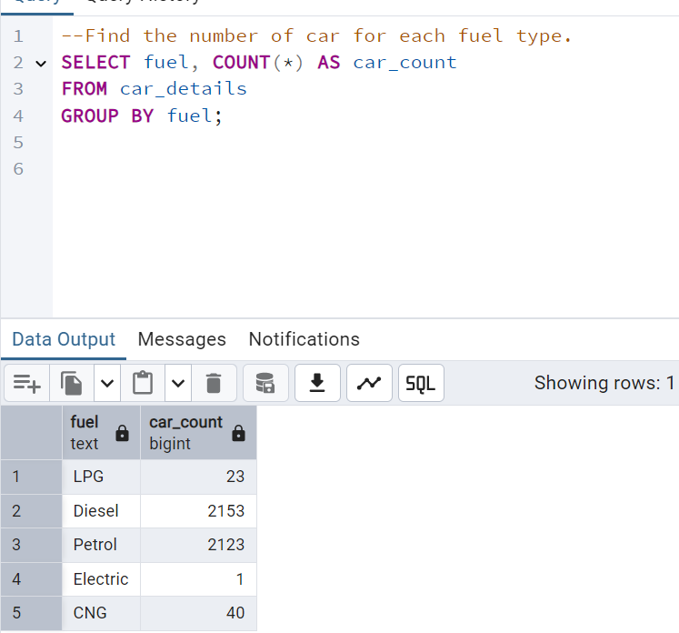

1. **Filtering and Aggregation**
   * Find the average selling price of diesel cars.

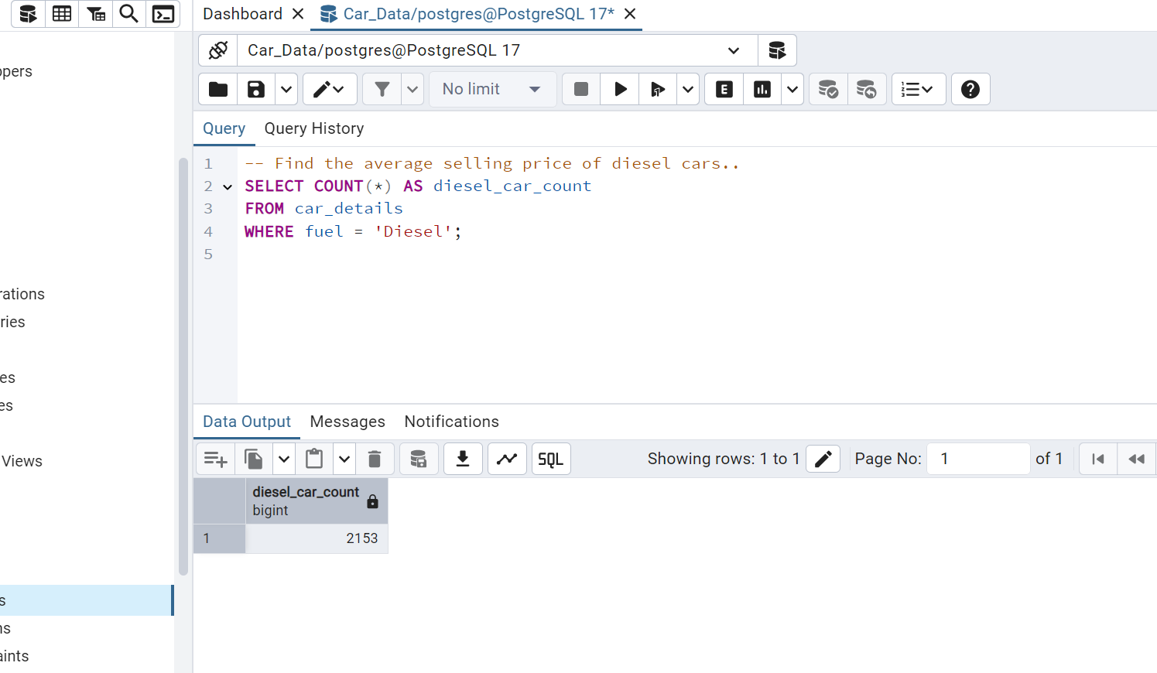

* + Show the total number of cars sold by individual sellers.

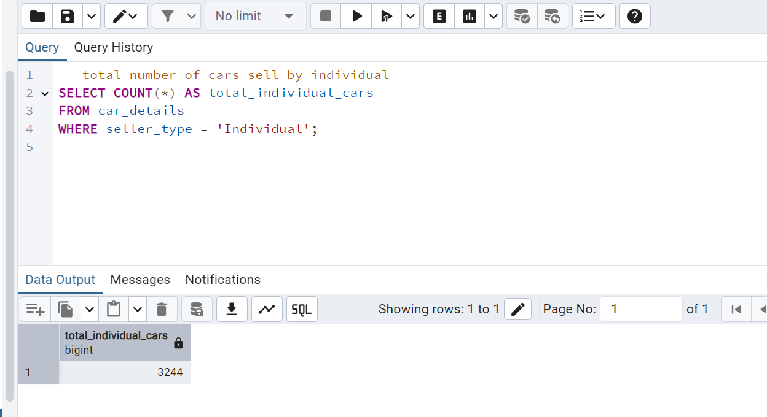

* + Find the oldest car still available for sale.

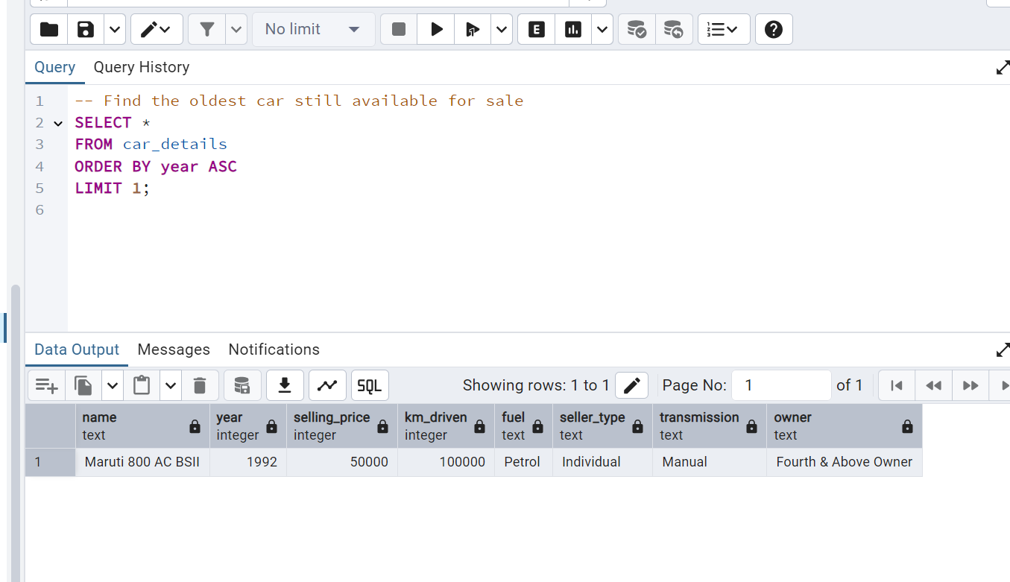

1. **Joins** 
   * Compare the selling price of manual vs automatic cars.
   * Find the most common car brand among sellers.
2. **Advanced Queries**
   * Identify the top 5 most driven cars.
   * Find the percentage of first-owner cars in the dataset.
   * Determine the most popular transmission type among diesel cars.